NStar Manual Programming Guide
Covers Installation, Programming, and adding Users (Cards)
By Chris Phipps 09/18/08

Getting Started: Installing NStar

- Install NStar in your system. Be aware that we strongly recommend you remove any Anti-Virus programs before the install and restore them after the install is verified to be finished and working.

>>>IT IS STRONGLY ADVISED THAT BEFORE BEGINNING THE INSTALLATION OF THE SOFTWARE THAT ANY ANTI-VIRUS SOFTWARE BE UNINSTALLED. MANY ANTI-VIRUS APPLICATIONS WILL PREVENT SQL SERVER FROM INSTALLING CORRECTLY AND MAY CORRUPT THE INSTALL. AFTER THE SOFTWARE IS INSTALLED AND WORKING, ANTI-VIRUS SOFTWARE MAY BE INSTALLED<<<

>>>IT IS HIGHLY SUGGESTED THAT THE TARGET PC FOR THE SOFTWARE INSTALL NOT BE A PC THAT SERVES VITAL FUNCTIONS FOR THE END USER. THERE ARE CASES WHERE WE REQUIRE REBOOTS OR ADMINISTRATOR ACCESS TO THE PC. IT IS PREFFERRED A STAND-ALONE PC IS USED SO NO OTHER END-USER APPLICATIONS CONFLICT WITH THE WIN-PAK OR VICE VERSA<<<

- Log in to the software using the NStar User Interface and use the default login of user Admin and no password.

- To license and register NStar, log on to NStar and choose Help >License and register the software at www.honeywellaccess.com or contact our Customer Service department at 1-800-223-9436. NStar runs in the demo mode and has restricted features, until you register the software.

Basic Configuration:
This section will guide you through the most bare-bones programming to get you started. After following these steps you will be able to see and control a single panel.

Starting Steps: Adding a Communication Server
Win-PAK uses a series of Services to control aspects of its communications with your equipment. These services must be created in the Device Map to function

1. Choose Configuration -> Device -> Device Map

2. Right click the Devices folder and select Add > Communications Server

3. A Name is required, and the ADD button on the right should be clicked. On the window that opens you should do nothing except click OK to proceed to the next screen. Click NEXT and you will see a list of Com Ports, click the ones you want to make available for use, then click NEXT again and FINISH. You now have a Communication Server. Other servers are added the same way and it may be wise to add a Schedule Server before moving on.

Click ADD then OK, don't change the contents of the window that opens. This applies to every time you click ADD. ADV is for advanced programming later.

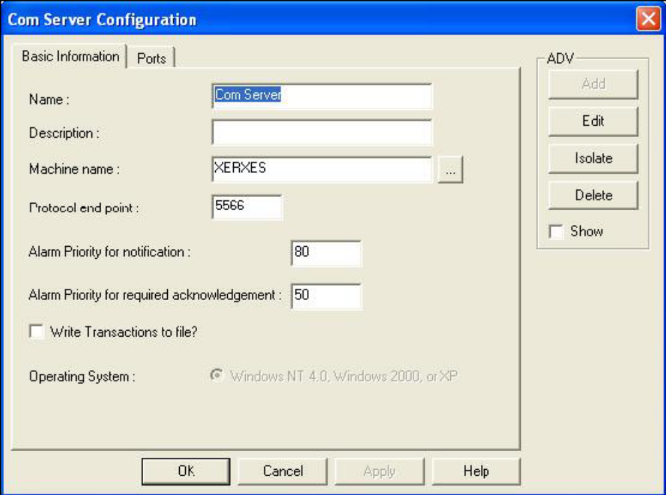
Required

Starting Steps: Creating a Loop
The LOOP is the device that chains your panels to each other and then connects to the computer to facilitate programming. The Nstar panels can run in one of three ways. Using a 485-PCI-2 to allow multiple panels to run on a stringed loop, or individually using either a CBL-50 or NSLAN-1. These loop types all configure identically and only differ in what you select when adding them to the device map.

1. Right click on your Communications Server from the previous step and select Add -> Panel Loop (485/PCI) if you are using the 485-PCI-2 OR Add -> RS-232(Single Panel) if you are using the CBL-50 or NSLAN-1.

2. The LOOP will have two sections, the BASIC and PORT SETTINGS. Images for these sections are on the next page. Under BASIC you will require a name, to check the two boxes in the lower left, and to click the ADD button just as before.

3. After clicking NEXT you will be on PORT SETTINGS On this section you need to specify a connection type, either Com Port or TCP/IP. If you select a com port, select a speed at either 19200 or 9600 that matches your 485 settings. If you select TCP/IP enter your IP address. Nothing else here need be changed. Click NEXT then FINISH.
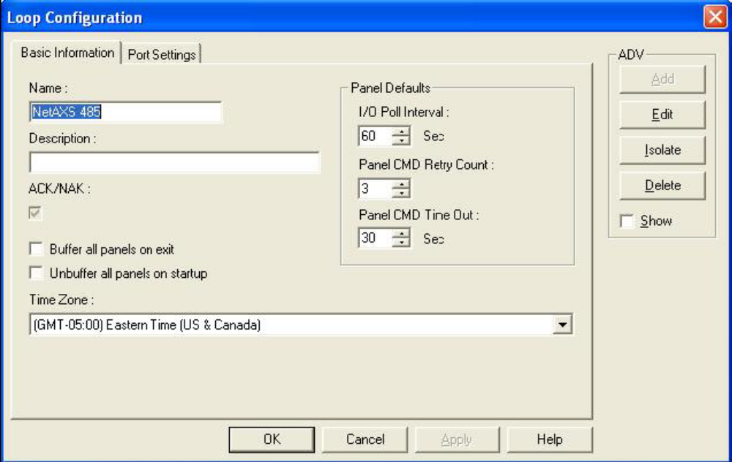
Required
As before, click ADD, then nothing but OK on the next window.

Check these boxes to force the panels to hold information if the Communication Server is shut down manually.

Only appears on 485 Loops.

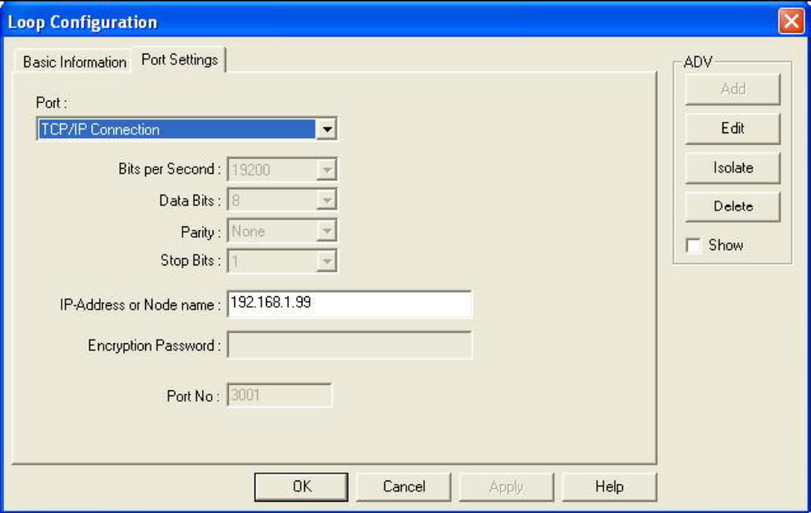

485 Loops can be either TCP/IP or Com Port depending on how they connect to the PC. CBL-50 loops MUST be com port. NSLAN-1 loops MUST be TCP-IP.
Speed is only set for Com Ports. Based on Dip 8 on the 485, up is 9600,down is 19200.

Starting Steps: Creating a Panel
- Now that the loop is complete you may right click it and select your panel type. The Nstar software only allows the addition of NS2 panels, so if you right click your newly created loop you will select Add New NS2 Panel. This is where most programming is done essentially so each section of the panel will have an associated image to help you navigate.

- The PANEL will have seven sections. We will address them one at a time. Under BASIC you will require a name, type, and address. Also click the ADD button just as before. The image on the previous page shows required settings. Click NEXT.
Name is required

Status should be Active
Type and Version are unchangeable.

Description is optional

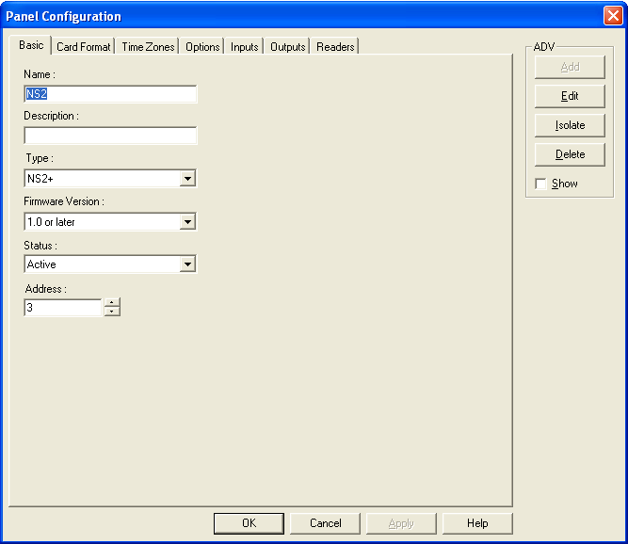
Address is required, check panel for correct address.

- The CARD FORMATS tab allows you to change the way the panel reads card data. Normally, nothing here should be changed. The image below will explain briefly what some fields are but no settings should be changed here. Just click NEXT. This section may be used to add 37 or 35 bit cards in the future if needed.
Inverse Card Formats is used with very old style readers where the card is inserted INTO the reader and then removed. These check boxes should NOT be checked under any other situation.

These Def. buttons allow you to revert the format for that line back to default.

The NS2 panel can contain 32 card formats…you will likely never come close to this.
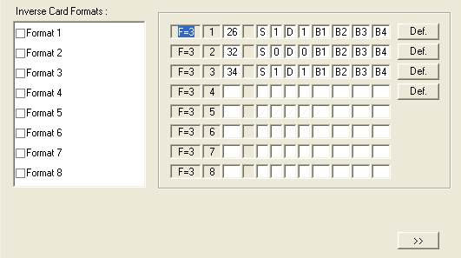

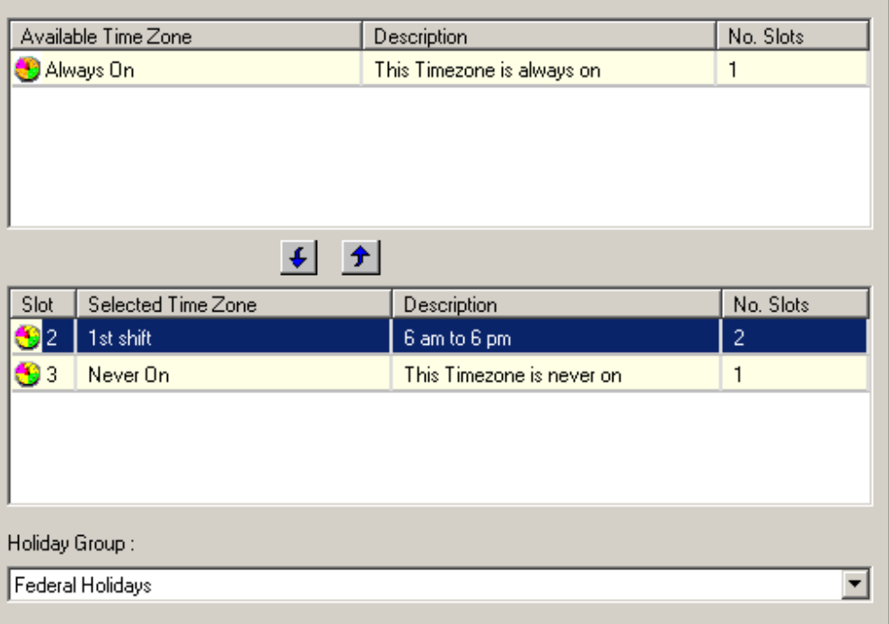
- The TIME ZONES tab is used to add or remove time zones from a panel. Newly created panels have all time zones at the top. They must be on the bottom to be usable. Click the time zone and then the down arrow to move a time zone.
Available Time Zones have not been assigned to the panel and are thus unusable on any of its devices.
Selected Time Zones are usable by the panel in other areas.
Holiday Groups are assigned to the panel so it knows when to read special time zone settings.
- The OPTIONS tab is used to enable advanced features of the panel. Normally, nothing should be changed here. Click NEXT for now.
Global Anti-Passback means all Anti-PAssback readers on every panel interact with each other.
Forgiveness causes all users to reset status at Midnight.
Increases card security by reading an invisible code on the card, if the code does not match in this list, it will be denied. Leave default for now.

Enables use of Keypads or Combo Readers. Only certain readers supported.
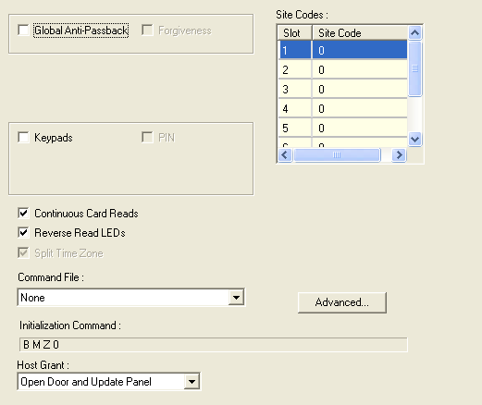
Advanced settings that should not be changed.

This section will likely not appear, Nstar does not use Command Files. However, these panels work in softwares that do allow them.

Contains options not normally used that can enable higher level cards.

If a card is not in the panel database, the panel will ask the software if it is valid and perform the set task.
- The INPUTS section controls the settings for your panels Status Inputs and Egress/REX Inputs. From this section to the end of the panel, your devices must be individually named if desired. This is done through use of the ADD button on the right hand side of the screen, just like the previous steps have explained. Normally, nothing here needs to be changed.

There is no need to uncheck anything. If you are not using status contacts, set Inputs 2 and 4 to Normally Open. When you are done, click NEXT.
>>>DO NOT USE THE ALWAYS ON TIME ZONE HERE!!!<<<
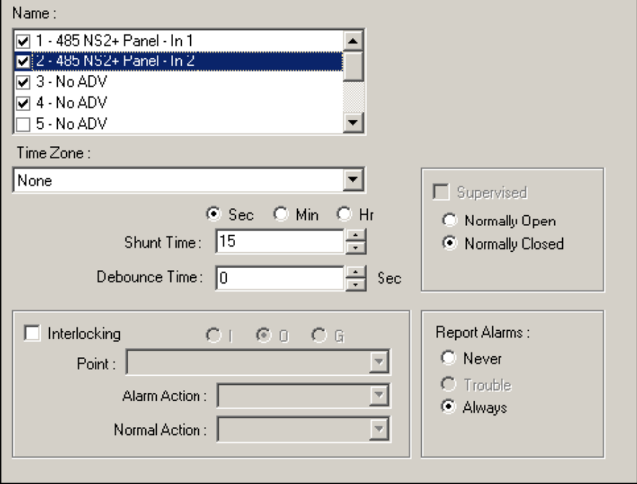
A Shunt time means that if this input is 'touched' by some action then it will disable for this many seconds. Normally this is only for Status Inputs influenced by a door opening.

Interlocking is 'What happens next' after this input goes into Alarm and then back to Normal.

Defines if this input should report changes of state to the software. Status points do, egresses do not by default.

This section defines the normal state of the input device. If Supervised is checked the point will search for resistance or report trouble.
Debounce means to delay reporting an alarm if it occurs to make sure the alarm is real. If the alarm is cleared before the time expires, no alarm is reported.

A Time Zone on an Input DISABLES it for that time frame. This is why the Always On should not be used.

This is a list of available Inputs on this panel.

- The OUTPUTS section controls how your doors will operate. By default you don't have to do anything here but hit NEXT unless you want to rename the Output Points.
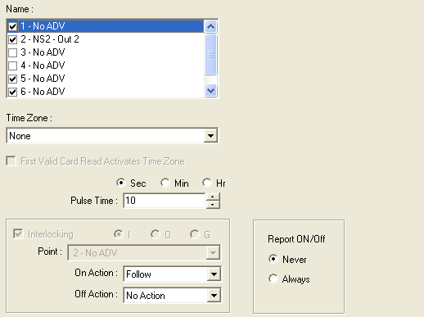
>>>DO NOT USE THE ALWAYS ON TIME ZONE HERE!!!<<<
This is a list of the Outputs available on this panel.

The pulse time how long the Output will change state based on a valid card read or REX activation.

A Time Zone on an Output causes it to ENERGIZE during that time frame, opening the door. The Always On Time Zone will cause a door to never lock.
Interlocking is 'What happens next' if this output were to energize ( On ) or de-energize ( Off ).

This feature allows an Output to be assigned a Time Zone that will cause it to automatically Lock and Unlock, but that time zone will be suppressed until a VALID CARD is used at that door. This is for situations where employees may arrive at different times to a building and the doors should not open until someone is there.

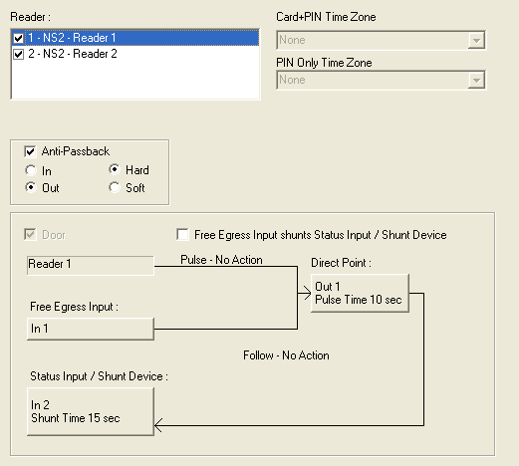
- A READER, as the software understands it, refers to how the inputs and outputs designated to a specific door interact with one another. If you are not using a reader on your panel, leave it alone in the software. Do not uncheck or ‘disable’ any readers, it will cause errors later more often than not.
If you have supported readers for true CARD+PIN applications you can assign times where the reader REQUIRES CARD+PIN, or just PIN to open the door.
This map shows how devices interact with each other. Your READER and FREE EGRESS activate a DIRECT POINT which shunts a STATUS INPUT to disable false alarms. Click any button that appears raised to change that point’s properties.
This check box will re-write the map to stop your Egress from firing its Direct Point relay. Instead, it will put the door contact to sleep to prevent false alarms.
If Anti-Passback is enabled, doors become IN or OUT. If you use an IN door, you may NOT use the IN door again until you use an OUT door. Hard means you are forbidden to use the door, Soft means you can use the door but the software will generate an alarm.

Starting Steps: Creating Access and Control Areas
Now that the system knows what equipment you are using and the settings for its behavior, you are ready to design how the software should appear to the end users for controlling this equipment and assigning access to the readers. Pressing the ADD button in the previous step creates items in the software called ADVs. These are used to do special programming, but more importantly, design your Access Levels and Control Map. This section explains both.

- We'll start with Access Area because it's easier. Select CONFIGURATION->DEFINE->ACCESS AREA from the top toolbar at the top.

- Right click the folder at the very top of this window labeled ACCESS AREA. If you wish to create sub-folders to organize your system you can select ADD BRANCH. Otherwise just select ADD ENTRANCES.

- In the ADD ENTRANCES window you will see a list of all the available Readers that ADVs have been made for. It is advised you create ALL your panels before you come to this point so all the ADVs can be added at once. Select the ADVs for the readers by clicking them, then clicking ADD. This will move them to the folder in Access Area. They may now be used under CARD->ACCESS LEVEL which will be addressed later on.

The Control Area defines the Control Map which is where you control your equipment. This section will explain how to add devices to it, but it is largely similar to the Access Area.

- From the top tool bar select CONFIGURATION->DEFINE->CONTROL AREA.

- Right click the Control Area folder and select ADD SITE. Name it whatever you so choose.

- Right click the folder you just created and select ADD DEVICES. This is exactly like the ADD ENTRANCES window from the previous steps but you now have a drop down called Devices that lists all possible ADV types. Using this drop down you will select your device type, highlight the device, and click ADD so it disappears from the list. If a device has no devices it means you did not hit the ADD button for that device or never made one to begin with.

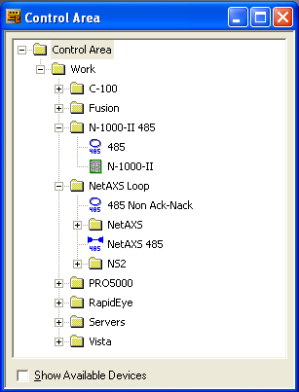
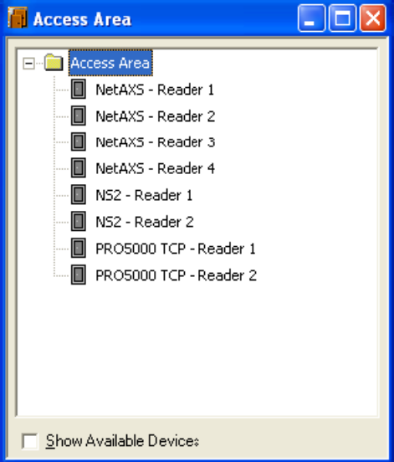
After these two procedures are complete you should now have windows that look somewhat similar to this. End results will vary.

Starting Steps: Creating a Time Zone
This step can truly be done at any time, and sometimes it is easier to perform it before doing any of the panel programming. It is placed here after programming the panel because it will review how to go back and add Time Zones to existing panels, an important piece of training.

- Now that Access Areas are built you may almost begin making cards but not yet. It is optional but there may be a need to create Time Zones to restrict how people access the doors on the system. This can be skipped but is here as reference. It may be required in the future if not now.

- Go to CONFIGURATION->TIME MANAGEMENT->TIME ZONES. Click ADD under OPERATIONS. This will bring up the window below where anew time zone may be named and created. Name it the hours it should cover.

- The bars on this window represent days of the week, weekends, and Holidays. You can right click a bar to type in a time frame using military time, or you may left click at a point on the bar, and drag your mouse from the start time to the end time. The yellow bar that appears is when a change occurs. OUTPUTS will ENERGIZE in this time. INPUTS will SHUNT or go to sleep. On an Access Level this defines when a card works at its assigned door.
Days of the Week:
M=Monday
T=Tuesday
W=Tuesday Th=Tuesday F=Tuesday S=Tuesday
Su=Tuesday
Snap Time tells your mouse cursor to snap to this increment of time while dragging it.

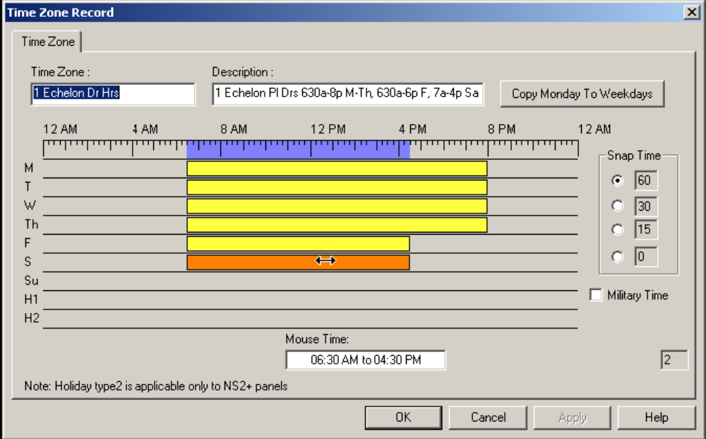
Holidays: To use these a Holiday Group must be created under CONFIGURATION-TIME MANAGEMENT-HOLIDAY GROUP. All holidays should be in one group, applied to Time Zones tab of panel configuration.
This is the number of time zone slots this time zone uses in a panel. Max is 63.

- After you have defined all of your days to the time they require, OK out of the window. Now that the time zone is created you must apply it to the panels to be usable. During the creation of the panel there was a section called Time Zones. You may get back there by selecting CONFIGURATION->DEVICE->DEVICE MAP, Right Click the Panel and select Configure, then go to the Time Zones tab. Your time zone must be moved to the bottom to be activated.

Starting Steps: Creating an Access Level
We are almost ready to add Cards. First we need to define when the cards are going to work and at what doors they will work. We will start with making a Master access level that can use any door at any time.

- Go to CARD->ACCESS LEVEL. Click the ADD button at the bottom of the left side of the window to make a new access level. A name is required, and it may be required to move an account from Available to Selected as well. Only Selected Accounts will see this access level and be able to edit it. Only PRO version software allows accounts.

- After the access level is named you will see the doors added under Access Area on the right and they will all be Red. Red doors are not usable by cards in this level. Since this is a Master level, right click the folder at the top of the list and select CONFIGURE, then SET ACCESS FOR ENTRANCES IN THISAREA, and select the Always On time zone. The doors will turn green. A door with Always On means cards in this level may be used.

- Other time zones may have doors that are not configured or use restricted time zones rather than Always On. Those will be designed by you as per the previous section.

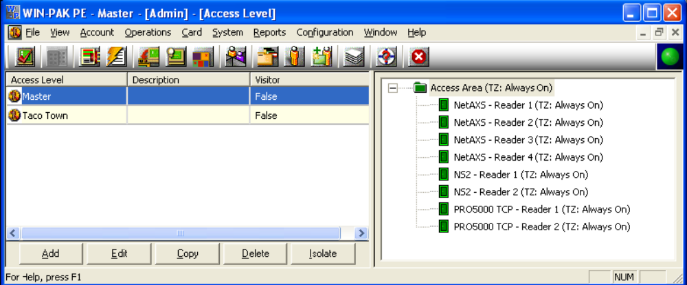
This is a list of your access levels.

The doors in the selected access level and the time zone they work during.

Starting Steps: Creating a Card and Card Holder
This is the last step in most programming, creating the users. Our work is going to be done under CARD->CARD HOLDER but there are several ways to add cards and card holders. This is the fastest to add both person and card.

- In the CARD HOLDER window press ADD under operations. In the window that appears we are concerned with only two tabs. The first tab is Basic Info, here enter the First and last name of the person who will use this card then click the CARDS tab.

- In the CARDS tab there are two primary options. ADD and ATTACH. ADD is used if you are creating a new card, ATTACH is used if the card has already been added. Click ADD.

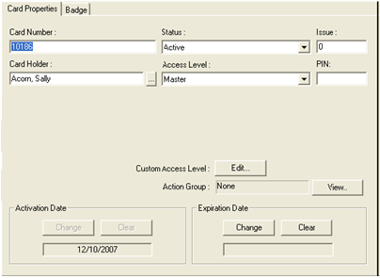
- This diagram shows the important parts of the card window. Only three are truly required. You must have a CARD NUMBER, a Status of ACTIVE and an ACCESS LEVEL of some kind. Nothing else must be changed. Hit OK when you have assigned the essentials.
Card Number is required. This number is on the card.

Do not fill in the Card Holder data. This will automatically be populated after you hit OK if you came here from making a Card Holder.

Cards may only have one Access Level in most situations.

Set to Active

If using PIN readers, this is where the PIN is set.

This is used for creating specialized Access Levels. It is best to leave this alone at this stage.

Starting Steps: Final Step, Initialize the Panel

This is the moment of truth. Before proceeding to the final step please reboot your PC. This will cause the services to re-sync and solve many first time install issues we may encounter.
Now that the system knows your equipment, it's time to make sure it works and send down the programming. This will all be done under OPERATIONS->CONTROL MAP. This guide will not cover troubleshooting so retrace your steps and if all else fails call tech support at the number at the start of the guide.

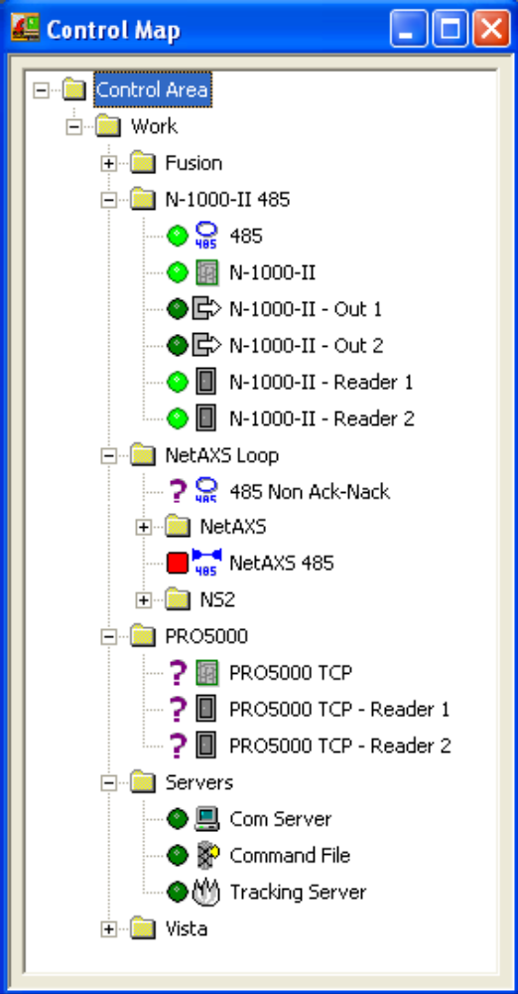
- The Control Map is a perfect copy of how you programmed CONFIGURATION->DEFINE->CONTROL AREA. Therefore we cannot tell you where things are because it is custom. However we can show an example of one and what to expect to see. The image below is an example system and of course will not match yours in layout, but gives us what we need to review.
+ means expandable, - means expanded, a folder contains other items.

The LOOP is typically a blue symbol with a number under it to designate the loop type.

Outputs control your locks, ENERGIZE should always result in an open door. RESTORE TO TIMEZONE puts the device back on its schedule.

Most devices will show you their status with a GREEN BALL, RED SQUARE, or PURPLE? Bright color means alarms that are new. Dark color means alarms you have already seen. Mouse over any icon to see what the problem is, the message appears in about 3 seconds.
The Communication Server should always be green, if it is ever a ? mark that means there is a problem with it, but this is normal on a new install, the first thing to do is reboot, and wait about 3 minutes after you reboot to log in.

Readers combine the function of the OUTPUT and STATUS INPUT for a door. They show the state of the status input, either normal, or open.

The PANEL looks like a circuit board somewhat. If you right click one you should see INITIALIZE. This is the only item that has that command.

- Since this is a new install we will assume your Communication Server is green, your panel may be RED or GREEN. If it is red, as long as you can mouse over the red square and see PANEL ALARM: PANEL TAMPER then you are communicating to it. Right click the panel and select INITIALIZE, then SELECT ALL. This will send down all programming. In most situations you can send only what you change, but to be safe, send everything.

- If the initialization window disappears with no errors you are finished. You have now programmed your panel with the settings from the software. Add the rest of your cards and refer back to this if you need refreshing on any section.

- If the initialization fails, review your programming. An error message may be generated, write it down and contact tech support. If it is not an available option, grayed out on the window, reboot the PC, if the problem is unresolved contact tech support.

